**Project and Developer Details:**

|  |  |
| --- | --- |
| **Project Name:** | File Management System |
| **Developer:** | Vema Venkatesh Gangodi |
| **E-Mail:** | [venkatesh.gv484@gmail.com](mailto:venkatesh.gv484@gmail.com) |

**Flowchart of the Application:**

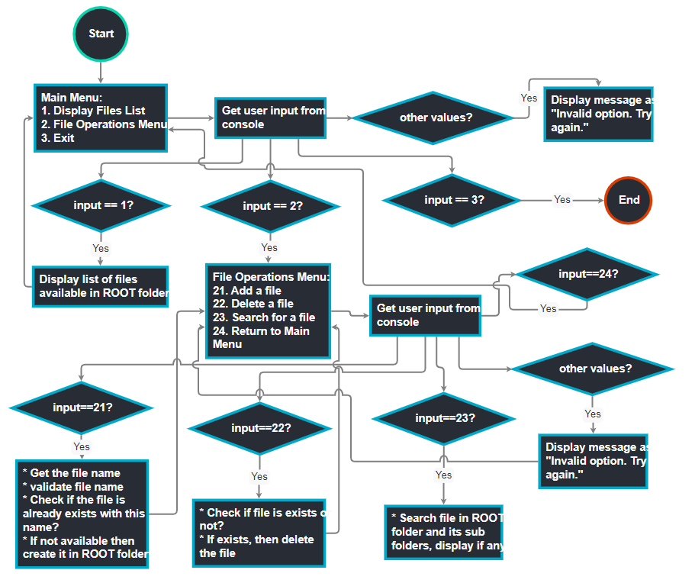

**Core concepts used in the project:**

* Core JAVA Concepts
* Scanner class to read the input from console
* Collection frame work (List, Map etc) to store the file names
* Multi-Threading (To perform parallel tasks)
* Exception Handling
* File operations
  + Create new file
  + Delete a file
  + Read a file
* Sorting Algorithm

**GitHub repository Link:**

<https://github.com/venkateshgv484/PGP-FSWD-PROJECT-1>

**Unique Selling Points:**

* **Display File List:**
  + This option is used to display the list of files available in ROOT folder and its sub folders.
  + It will display the files in ascending order
* **Adding a file:**
  + This option is used to add a file in ROOT folder
  + File name should be a valid file name and below are the examples of valid file names

**Examples:**

* Test.txt
* Sub Folder/Test.txt
* Sub Folder/Sub Folder2/Test.txt
* **Deleting a file:**
  + This option is used to delete a file from ROOT folder
  + Need to provide the full path of the file name in ROOT folder, which is displayed in **"Display File List"** option

**Examples:**

* Test.txt
* Sub Folder/Test.txt
* Sub Folder/Sub Folder2/Test.txt

* **Searching for a file:**
  + This option is used to search a file in ROOT folder and its sub folders.
  + We can search files by sub-part of the file name as below
* **Starts with** (Test*, etc)
* **Ends with** (*.txt, *.docx, etc)
* **Contains** (*Test*, *.*, etc)

**Output:**

